DATA BASE MANAGEMENT SYSTEM

LAB EXPERIMENTS

---Done by (192211927)

DOMMARAJU SUSHMANTH VARMA

1. Create a Table as Workers with the fields S No, Name, Designation, and Branch. Alter the Table by adding a column Branch. Drop the table.

Ans. Table workers

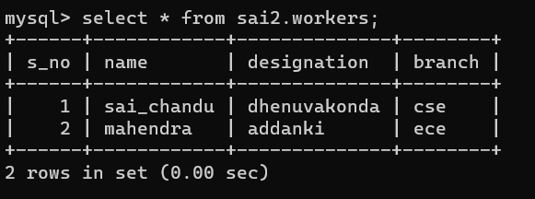

Alter the table by adding column salary

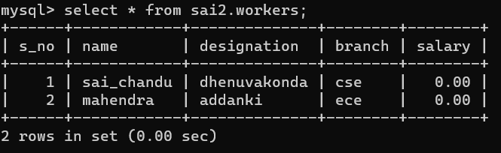

Dropping the table workers

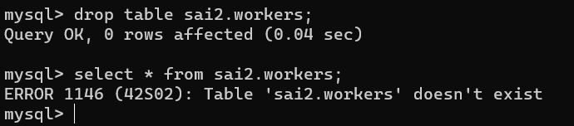

1. Create a table Bank with the fields S No, Cust Name, Acc No, Balance, customer Branch. Insert five rows into the table. Give a select statement using Simple Select * for selecting all fields in the table. Then **Update** the Customer Branch in the second row as Pondicherr**y.** SELECT with various clause.

Ans.

Create a bank with given fields and inserting 5 rows

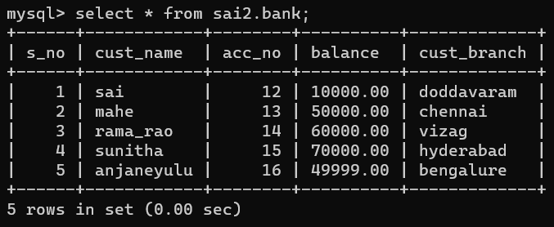

Updating customer branch in second row as Pondicherry

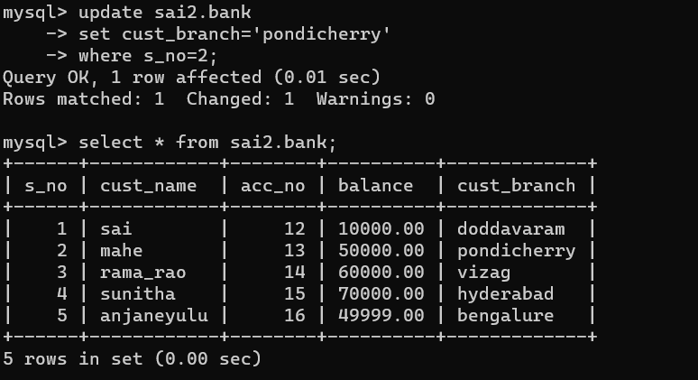

Selecting table with various clauses

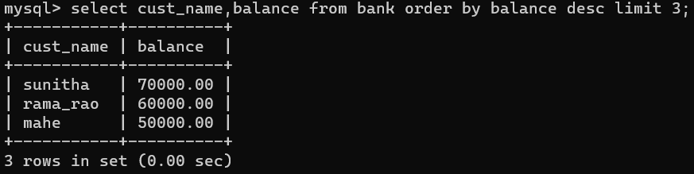

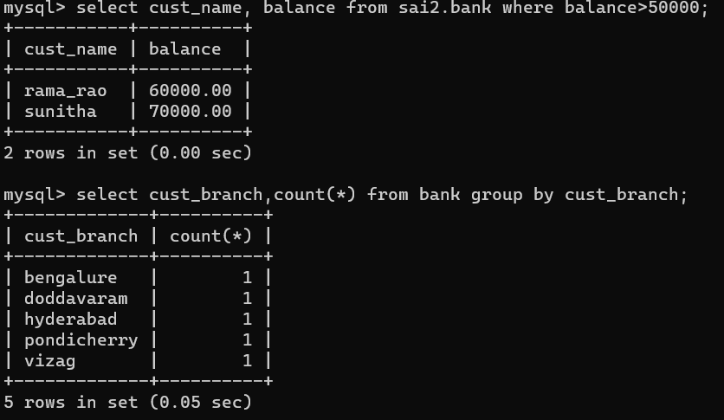

1. Create a Table Employee with fields S No, name, Designation Branch with primary key as S No. Create a table Workers with the same fields and make the field S No as foreign key.

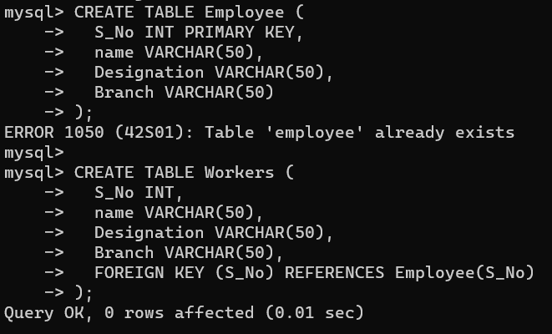

1. Create a Table Book with the fields S No, B Name, Author, Price, and Publisher. Create a **save point** for the table **book** as **B. Rollback** the table **book** after inserting four and five rows respectively. Execute the commands Grant & Revoke and finally Commit the table.
2. Create a table bank with fields S No, Cust Name, Acc No, Balance, cas Branch. Give the select statement with Simple Select * with where clause for the field name Acc No.

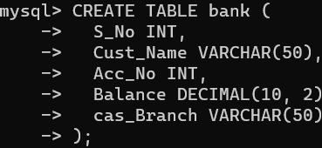



1. Create table Project with the fields S No, P Name, Coordinators, P Price, and Location. Select the rows in the table using Group by clause for Location. Select the rows in the table order by Coordinators.

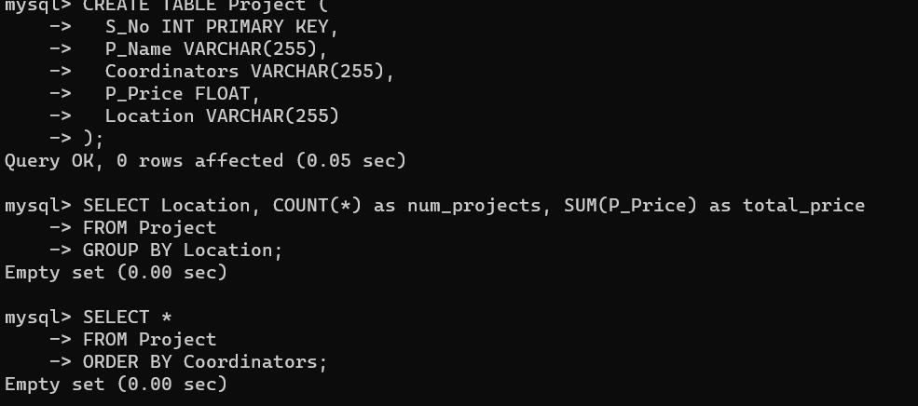

1. Create a Table Employee with fields S No, name, Designation Branch. Select employee’s names whose designation is manager and working in the branch Chennai.

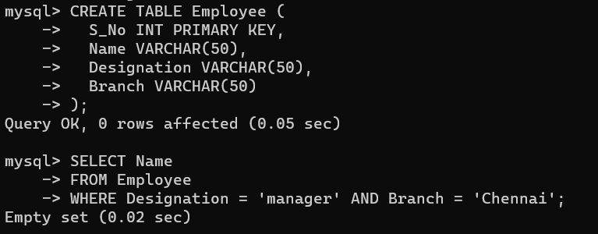

1. Create a view table with the fields S No, name, Designation, Branch in the Employee table and insert more records in the table

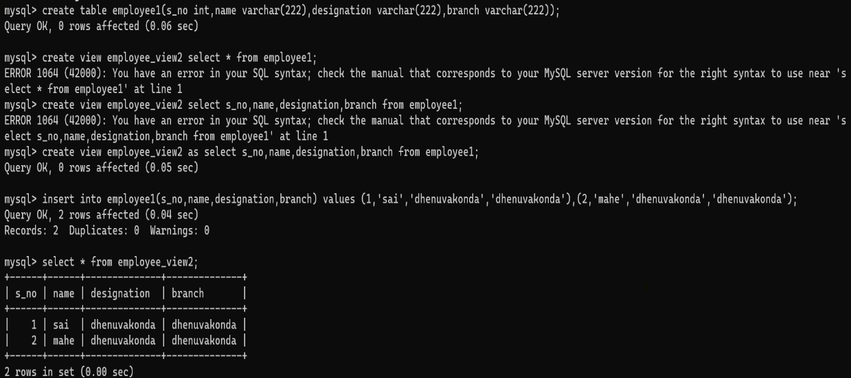

1. Create a recursive MySQL computing the factorial of a given number using high level programing Extension with Function. Create a simple **procedure** to get all the records from the table ‘Employee’ and list out the name, department, salary where salary > 20000 in the Table.

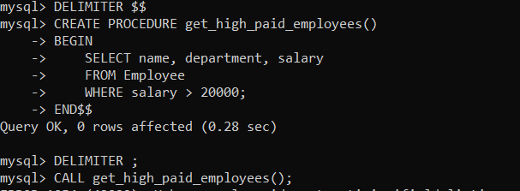

10.Cursor – Implicit and Explicit

Create a table employee and insert 30 records and implement the above cursor concepts with example.

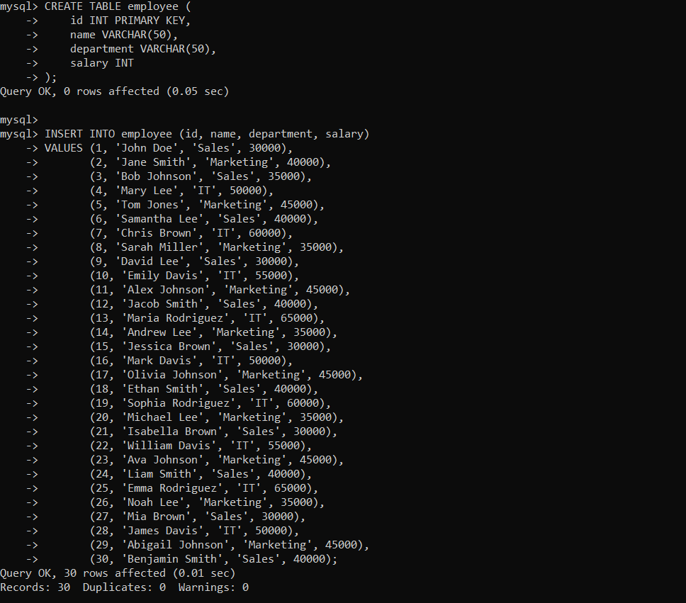

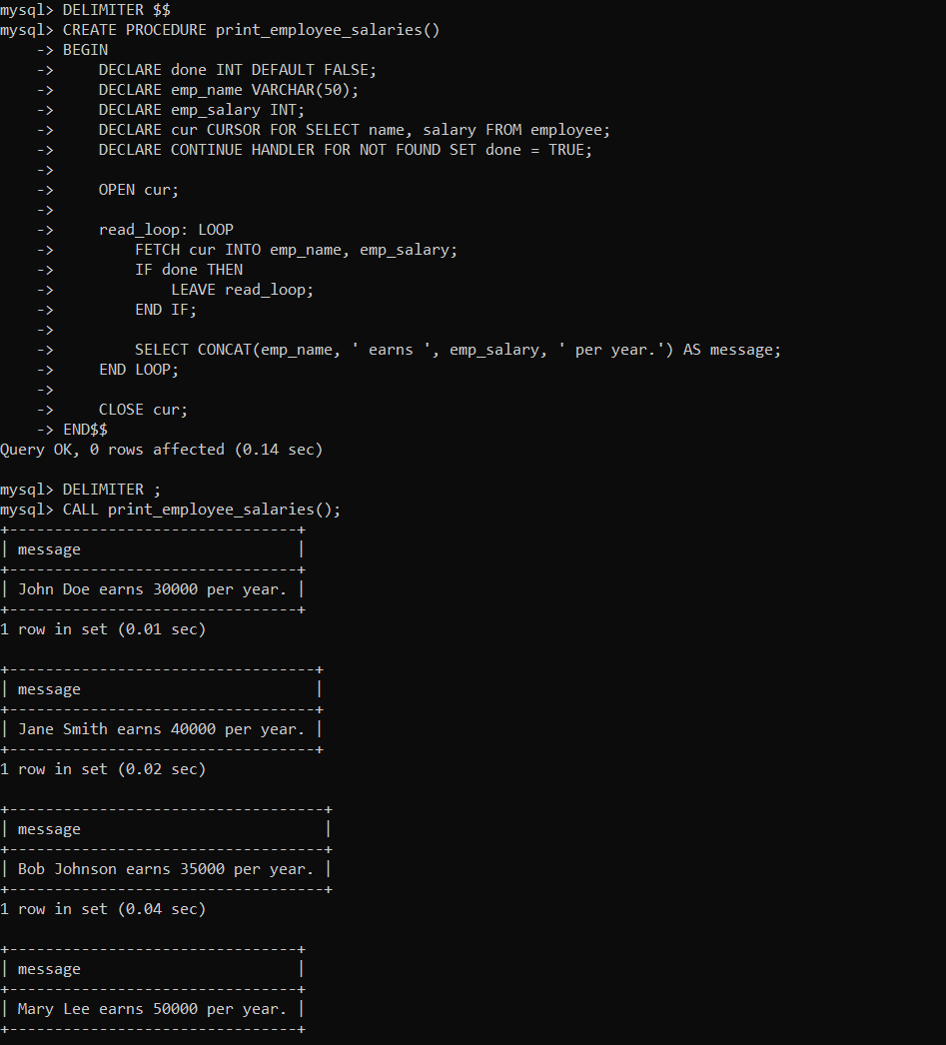

**11.Trigger**

Create a trigger in MySQL to log the changes of the EMPLOYEES table with fields ID, Name and Email. Also create a new table named EMPLOYEES_AUDIT to keep the changes of the employee table. Create BEFORE UPDATE trigger that is invoked before a change is made to the employees table.

